Document title

This document is generated with ReporteRs.

# Table of contents

# List of graphics

# List of tables

# Text demo

Lorem ipsum dolor sit amet, consectetur adipiscing elit.

In sit amet ipsum tellus. Vivamus dignissim arcu sit.

Quisque dictum tristique ligula.

* Lorem ipsum dolor sit amet, consectetur adipiscing elit.
* In sit amet ipsum tellus. Vivamus dignissim arcu sit.
* Quisque dictum tristique ligula.

My tailor is **rich**

Cats and Dogs

Silentium tractibus per minimis ne excita  
ut temptentur generalibus quam primordiis per clades post delictis  
iuge exitium silentium per et.

*Gallus necem refert singula modum quae est quae quorum leo.*

1. Lorem ipsum dolor sit amet, consectetur adipiscing elit.
2. In sit amet ipsum tellus. Vivamus dignissim arcu sit.
3. Quisque dictum tristique ligula.
   1. Lorem ipsum dolor sit amet, consectetur adipiscing elit.
   2. In sit amet ipsum tellus. Vivamus dignissim arcu sit.
   3. Quisque dictum tristique ligula.

# Plot example

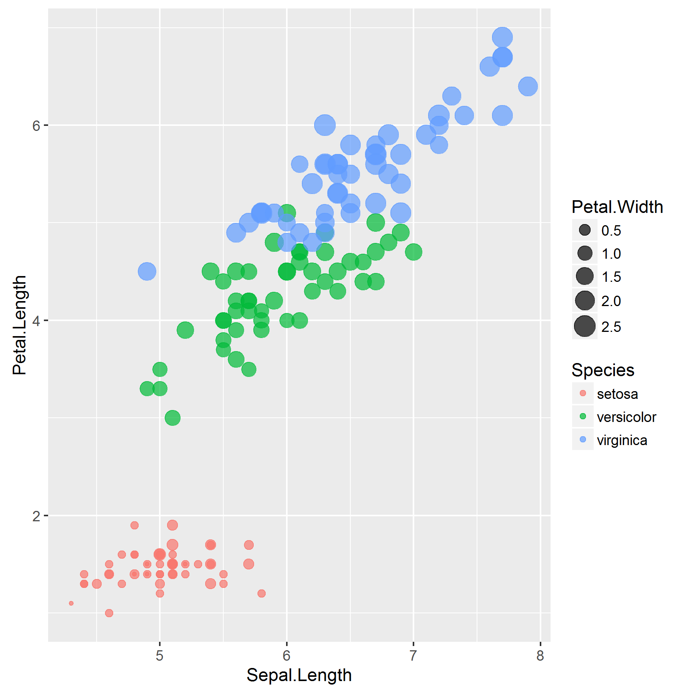

1. my first plot

# FlexTable example

|  | **mpg** | **cyl** | **disp** | **hp** | **drat** | **wt** | **qsec** | **vs** | **am** | **gear** | **carb** |
| --- | --- | --- | --- | --- | --- | --- | --- | --- | --- | --- | --- |
| Mazda RX4 | 21.0 | 6 | 160.0 | 110 | 3.90 | 2.620 | 16.46 | 0 | 1 | 4 | 4 |
| Mazda RX4 Wag | 21.0 | 6 | 160.0 | 110 | 3.90 | 2.875 | 17.02 | 0 | 1 | 4 | 4 |
| Datsun 710 | 22.8 | 4 | 108.0 | 93 | 3.85 | 2.320 | 18.61 | 1 | 1 | 4 | 1 |
| Hornet 4 Drive | 21.4 | 6 | 258.0 | 110 | 3.08 | 3.215 | 19.44 | 1 | 0 | 3 | 1 |
| Hornet Sportabout | 18.7 | 8 | 360.0 | 175 | 3.15 | 3.440 | 17.02 | 0 | 0 | 3 | 2 |
| Valiant | 18.1 | 6 | 225.0 | 105 | 2.76 | 3.460 | 20.22 | 1 | 0 | 3 | 1 |
| Duster 360 | 14.3 | 8 | 360.0 | 245 | 3.21 | 3.570 | 15.84 | 0 | 0 | 3 | 4 |
| Merc 240D | 24.4 | 4 | 146.7 | 62 | 3.69 | 3.190 | 20.00 | 1 | 0 | 4 | 2 |
| Merc 230 | 22.8 | 4 | 140.8 | 95 | 3.92 | 3.150 | 22.90 | 1 | 0 | 4 | 2 |
| Merc 280 | 19.2 | 6 | 167.6 | 123 | 3.92 | 3.440 | 18.30 | 1 | 0 | 4 | 4 |
| Merc 280C | 17.8 | 6 | 167.6 | 123 | 3.92 | 3.440 | 18.90 | 1 | 0 | 4 | 4 |
| Merc 450SE | 16.4 | 8 | 275.8 | 180 | 3.07 | 4.070 | 17.40 | 0 | 0 | 3 | 3 |
| Merc 450SL | 17.3 | 8 | 275.8 | 180 | 3.07 | 3.730 | 17.60 | 0 | 0 | 3 | 3 |
| Merc 450SLC | 15.2 | 8 | 275.8 | 180 | 3.07 | 3.780 | 18.00 | 0 | 0 | 3 | 3 |
| Cadillac Fleetwood | 10.4 | 8 | 472.0 | 205 | 2.93 | 5.250 | 17.98 | 0 | 0 | 3 | 4 |
| Lincoln Continental | 10.4 | 8 | 460.0 | 215 | 3.00 | 5.424 | 17.82 | 0 | 0 | 3 | 4 |
| Chrysler Imperial | 14.7 | 8 | 440.0 | 230 | 3.23 | 5.345 | 17.42 | 0 | 0 | 3 | 4 |
| Fiat 128 | 32.4 | 4 | 78.7 | 66 | 4.08 | 2.200 | 19.47 | 1 | 1 | 4 | 1 |
| Honda Civic | 30.4 | 4 | 75.7 | 52 | 4.93 | 1.615 | 18.52 | 1 | 1 | 4 | 2 |
| Toyota Corolla | 33.9 | 4 | 71.1 | 65 | 4.22 | 1.835 | 19.90 | 1 | 1 | 4 | 1 |
| Toyota Corona | 21.5 | 4 | 120.1 | 97 | 3.70 | 2.465 | 20.01 | 1 | 0 | 3 | 1 |
| Dodge Challenger | 15.5 | 8 | 318.0 | 150 | 2.76 | 3.520 | 16.87 | 0 | 0 | 3 | 2 |
| AMC Javelin | 15.2 | 8 | 304.0 | 150 | 3.15 | 3.435 | 17.30 | 0 | 0 | 3 | 2 |
| Camaro Z28 | 13.3 | 8 | 350.0 | 245 | 3.73 | 3.840 | 15.41 | 0 | 0 | 3 | 4 |
| Pontiac Firebird | 19.2 | 8 | 400.0 | 175 | 3.08 | 3.845 | 17.05 | 0 | 0 | 3 | 2 |
| Fiat X1-9 | 27.3 | 4 | 79.0 | 66 | 4.08 | 1.935 | 18.90 | 1 | 1 | 4 | 1 |
| Porsche 914-2 | 26.0 | 4 | 120.3 | 91 | 4.43 | 2.140 | 16.70 | 0 | 1 | 5 | 2 |
| Lotus Europa | 30.4 | 4 | 95.1 | 113 | 3.77 | 1.513 | 16.90 | 1 | 1 | 5 | 2 |
| Ford Pantera L | 15.8 | 8 | 351.0 | 264 | 4.22 | 3.170 | 14.50 | 0 | 1 | 5 | 4 |
| Ferrari Dino | 19.7 | 6 | 145.0 | 175 | 3.62 | 2.770 | 15.50 | 0 | 1 | 5 | 6 |
| Maserati Bora | 15.0 | 8 | 301.0 | 335 | 3.54 | 3.570 | 14.60 | 0 | 1 | 5 | 8 |
| Volvo 142E | 21.4 | 4 | 121.0 | 109 | 4.11 | 2.780 | 18.60 | 1 | 1 | 4 | 2 |

1. my first table